Іванов Кирил

ФІТ 2-8

Варіант 8

|  |  |  |
| --- | --- | --- |
| 1. 1) | 2) | 3) |

from scipy import integrate

import numpy as np

eps = 0.001

a = 0.4

b = 1.2

def f2(x):

return 1 / np.sqrt(x + 3)

def left_rec(f, a, b, n):

h = (b - a) / n

_sum = 0

for i in range(0, n):

_sum += f(a + i * h)

return _sum * h

if abs(left_rec(f2, a, b, 2 * 10) - left_rec(f2, a, b, 10)) / 3. <= eps:

print("Лівий прямокутник:", round(left_rec(f2, a, b, 10), 5))

def right_rec(f, a, b, n):

h = (b - a) / n

_sum = 0

for i in range(1, n + 1):

_sum += f(a + i * h)

return _sum * h

print("Правильний прямокутник:", round(right_rec(f2, a, b, 10), 5))

def aver_rec(f, a, b, n):

h = (b - a) / n

_sum = 0

for i in range(0, n):

_sum += f(a + i * h)

return _sum * h

print("Середній прямокутник:", round(aver_rec(f2, a, b, 10), 5))

result_quad, _ = integrate.quad(f2, a, b)

print("Результат четвірки:", round(result_quad, 5))

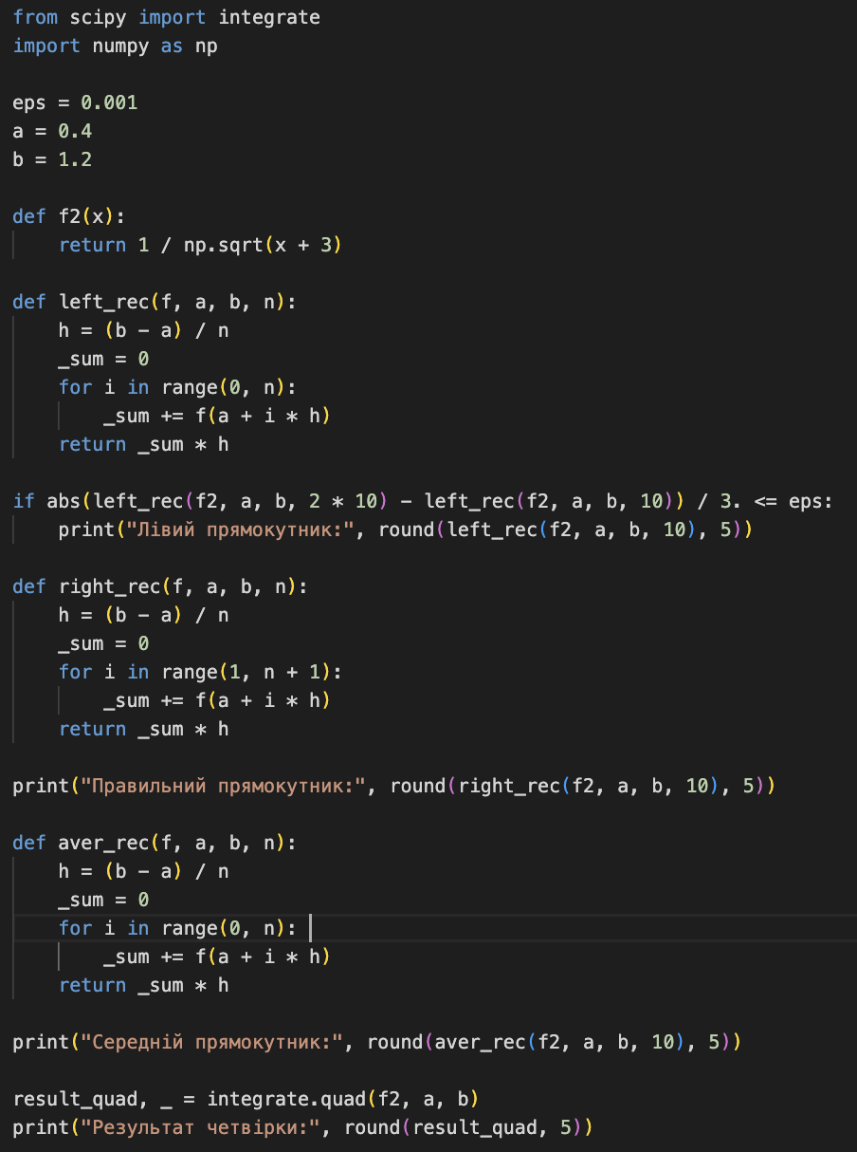

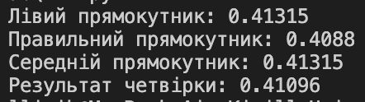

import numpy as np

from scipy import integrate

def f(x):

return np.cos(x) / (x + 2)

a = 0.4

b = 1.2

n = 8

def adaptive_simpson_rule(f, a, b, tol=1e-6):

h = (b - a) / n

integral1 = h / 3 * (f(a) + 4 * f((a + b) / 2) + f(b))

return recursive_adaptive_simpson(f, a, b, tol, integral1, f(a), f((a + b) / 2), f(b))

def recursive_adaptive_simpson(f, a, b, tol, integral1, fa, fc, fb):

c = (a + b) / 2

h = (b - a) / 2

d = (a + c) / 2

e = (c + b) / 2

fd = f(d)

fe = f(e)

integral2 = h / 3 * (fa + 4 * fd + fc)

integral3 = h / 3 * (fc + 4 * fe + fb)

if np.abs(integral2 + integral3 - integral1) <= 15 * tol:

return integral2 + integral3

else:

tol /= 2

return (

recursive_adaptive_simpson(f, a, c, tol, integral2, fa, f((a + c) / 2), fc) +

recursive_adaptive_simpson(f, c, b, tol, integral3, fc, f((c + b) / 2), fb)

)

result = adaptive_simpson_rule(f, a, b)

print("Адаптивний метод Сімпсона:", round(result, 6))

v, err = integrate.quad(f, a, b)

print("Перевірте наявність адаптивного методу Сімпсона:", round(v, 6))

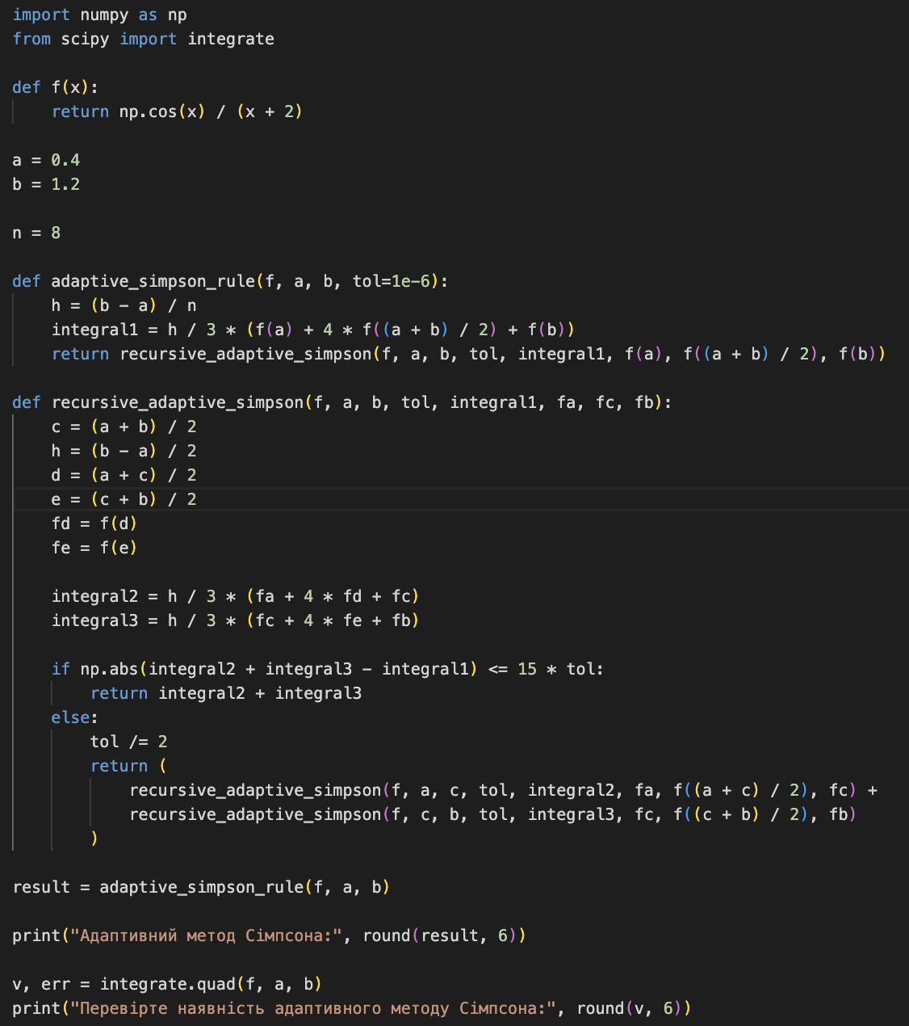



from scipy import integrate

import numpy as np

def f(x):

return 1 / np.sqrt(x**2 - 2)

a = 2.1

b = 3.6

n = 10

def trapezoidal_rule(f, a, b, n):

h = (b - a) / n

x = a + h

integral = 0

for i in range(1, n - 1):

integral += 2 * f(x)

x += h

integral += f(b)

integral *= h / 2

return integral

integral1 = trapezoidal_rule(f, a, b, n)

n *= 2

integral2 = trapezoidal_rule(f, a, b, n)

while abs(integral2 - integral1) / 3 > 0.001:

integral1 = integral2

n *= 2

integral2 = trapezoidal_rule(f, a, b, n)

print("Tрезультат рапезоїдного методу:", round(integral2, 5))

v, err = integrate.quad(f, a, b)

print("Перевірте метод трапеції:", round(v, 5))

